Projeto Arduino, Semaforo

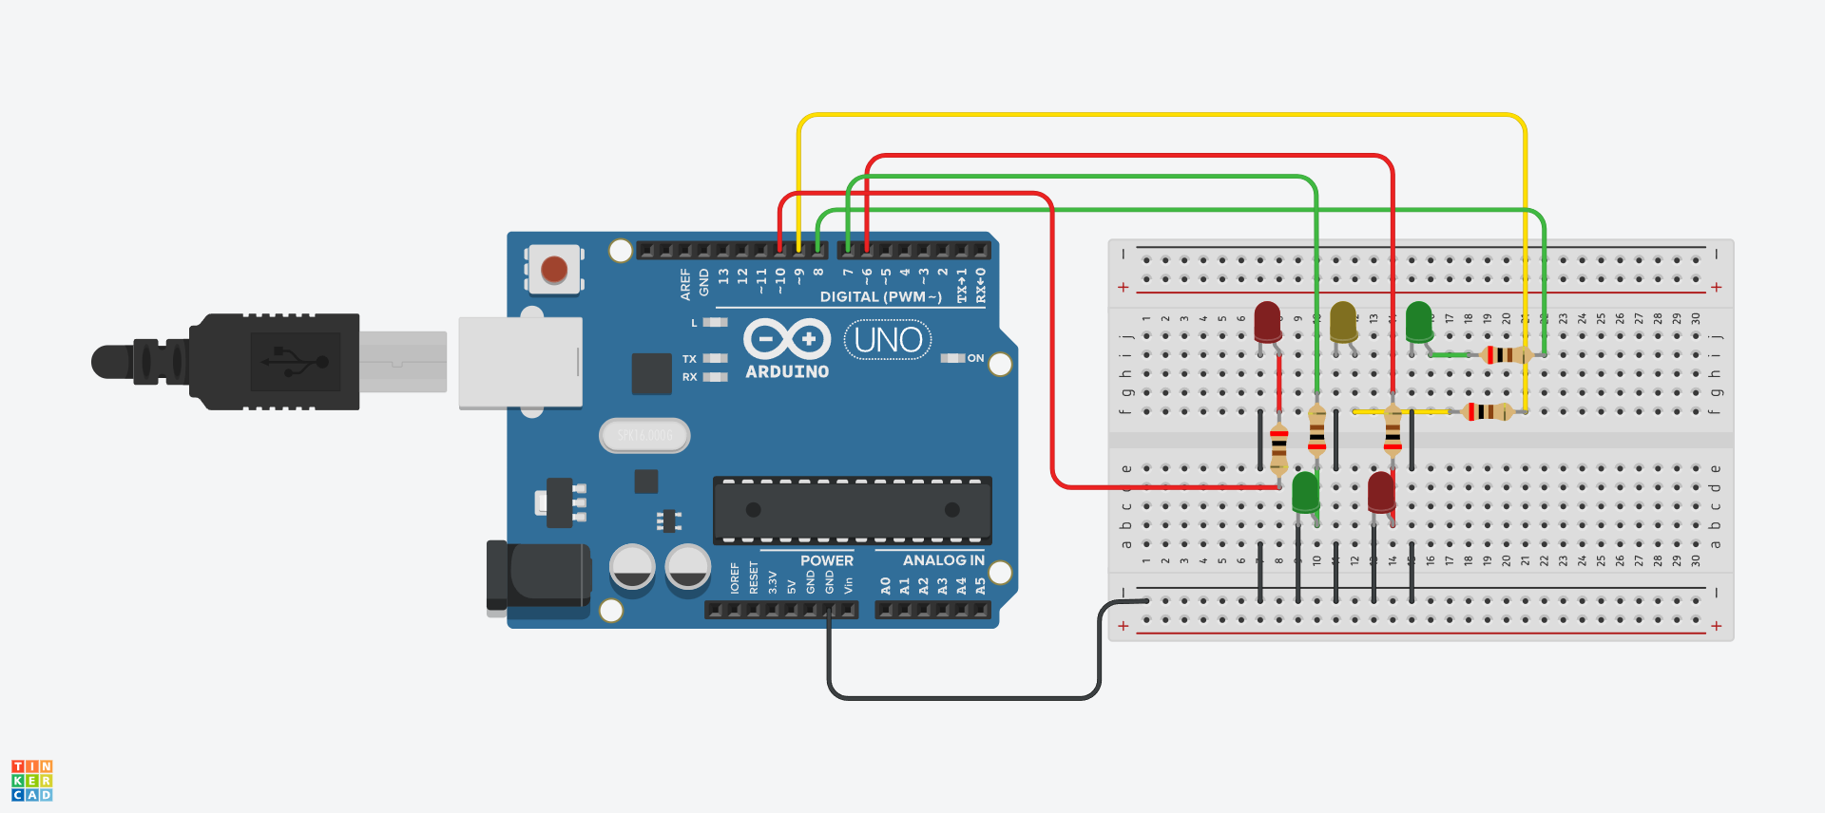

int ledgreen = 8;

int ledyellow = 9;

int ledred = 10;

int ledgreen2 = 7;

int ledred2 = 6;

void setup()

{

pinMode(ledgreen, OUTPUT);

pinMode(ledgreen2, OUTPUT);

pinMode(ledred, OUTPUT);

pinMode(ledred2, OUTPUT);

pinMode(ledyellow, OUTPUT);

}

void loop()

{

digitalWrite(ledred, HIGH);

digitalWrite(ledgreen2, HIGH);

delay(5000);

digitalWrite(ledred, LOW);

digitalWrite(ledyellow, HIGH);

digitalWrite(ledgreen2, LOW);

delay(500);

digitalWrite(ledgreen2, HIGH);

delay(500);

digitalWrite(ledgreen2, LOW);

delay(500);

digitalWrite(ledgreen2, HIGH);

delay(500);

digitalWrite(ledgreen2, LOW);

delay(500);

digitalWrite(ledgreen2, HIGH);

delay(500);

digitalWrite(ledgreen2, LOW);

digitalWrite(ledyellow, LOW);

digitalWrite(ledgreen, HIGH);

digitalWrite(ledred2, HIGH);

delay(5000);

digitalWrite(ledgreen, LOW);

digitalWrite(ledred2, LOW);

delay(1000);

}